

**Become a Green Gardener**

Classes are held via Zoom® Videoconferencing

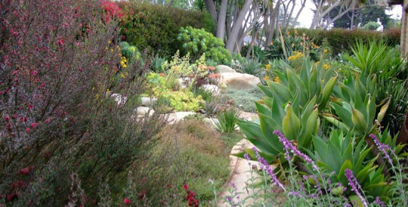

The Green Gardener Program offers education, training, certification, and the promotion of participating gardeners and landscape contractors. This regional program trains gardeners in resource-efficient landscaping practices within Santa Barbara County. Upon completion of the course requirements, Green Gardeners will be included on the County of Santa Barbara’s website.

**Spring 2021**

**Classes start Monday, January 11**

**5:00 pm – 7:20 pm**

**EHV NC001 - Green Gardener: Module 1**

**CRN 66858** Mondays **1/11-3/8**

**CRN 66859** Wednesdays **1/13-3/10**

**EHV NC002 - Green Gardener: Module 2**

**CRN 66860** Mondays **3/15-5/03**

**CRN 82046** Wednesdays **3/17-5/8**

**EHV NC104 Advanced Green Gardener**

**CRN 66060** Tuesdays and Thursdays **1/12-5/8**



**Register at** [www.sbcc.edu/ExtendedLearning/](https://www.sbcc.edu/extendedlearning/)  
Click on “Tuition-Free Classes.”

For more information email [csi@sbcc.edu](mailto:csi@sbcc.edu)

[Earn a certificate of completion](https://csi.cccbadges.org/sbcc-catalog/item/green-gardener)